Application of rules in badminton for four specific situations (P2, M1, D1)
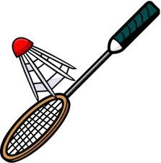
Situation 1: During a rally, player A hits the shuttle into the net. What is the decision?

Outcome

Situation 2: Score is 10-9 to the server. What box do they stand in to serve the next serve?

Outcome

Situation 3: During a rally, the shuttlecock hits the ceiling. What is the umpires decision?

Outcome

Situation 4: During a game of doubles, the shuttlecock lands in the tramline. What is the decision?

Outcome

2 recommendations the official could make
1

2

